**Solution 4**

Star Schema is used.

FitnessFact is the fact table.

Franchise, Items, Customer and Calendar are dimension tables.

Table follows which clearly shows the primary key and columns in it.

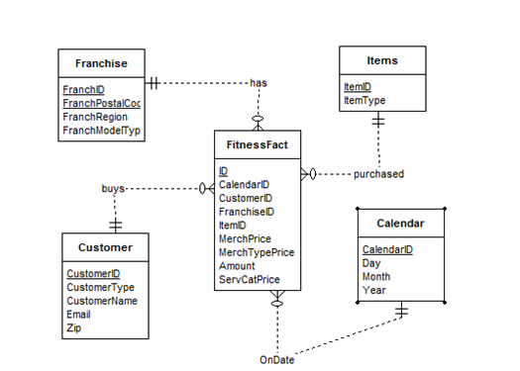

Customer (

CustomerID VARCHAR2(10) NOT NULL,

CustomerType VARCHAR2(20) NOT NULL,

CustomerName CHAR(30) NOT NULL,

Email VARCHAR2(30) NOT NULL,

Zip INT NOT NULL,

CONSTRAINT CustIDPK PRIMARY KEY(CustomerId));

Items (

ItemID VARCHAR2(10) NOT NULL,

ItemType VARCHAR2(20) NOT NULL,

CONSTRAINT ItemIDPK PRIMARY KEY(ItemID));

Franchise (

FranchID VARCHAR2(10) NOT NULL,

FranchPostalCode VARCHAR2(20) NOT NULL,

FranchRegion CHAR(30) NOT NULL,

FranchModelType VARCHAR2(30) NOT NULL,

CONSTRAINT FrIDPK PRIMARY KEY(FranchID));

Calendar (

CalendarID VARCHAR2(10) NOT NULL,

DAY INT NOT NULL,

MONTH INT NOT NULL,

YEAR INT NOT NULL,

CONSTRAINT CalendarIDPK PRIMARY KEY(CalendarID));

FitnessFact (

ID VARCHAR2(10) NOT NULL,

CalendarID VARCHAR2(10) NOT NULL,

CustomerID VARCHAR2(10) NOT NULL,

FranchiseID VARCHAR2(10) NOT NULL,

IemID VARCHAR2(10) NOT NULL,

MerchPrice INT NOT NULL,

MerchTypePrice INT NOT NULL,

Amount INT NOT NULL,

ServCatPrice INT NOT NULL,

CONSTRAINT IDPK PRIMARY KEY(ID));